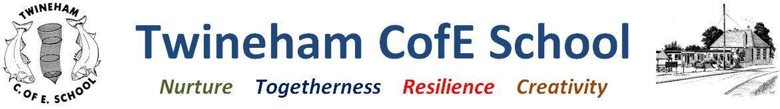
Our Curriculum of Hope

Outcomes | Texts | Curriculum intent
- Plan, write and edit their own stories about evacuation.  - Create character description and recounts based on Tail-end Charlie  - Write a script for a radio broadcast.  - Understand when World War 2 was, what the key events were and what life was like.  - Create their own War posters and blackout torches  - Know the geography of WW2 and the countries involved. | Letters from the lighthouse – Emma Carroll  Tail-end Charlie – Mick Manning & Brita Granstrom  Warboy – Michael Foreman  Adventures in Time (the Second World War) – Dominic Sandbrook  Eye Witness WW2 – Simon Adams | Children will learn about the importance of WW2 and how it affected our national history. They will also look at how it impacted the lives of ordinary people in the United Kingdom. Children will learn how both those in power and those that may not have thought they were significant effected the outcome of this giant struggle.
Key vocabulary | Year 3 and 4: Willow Class  (Autumn 2023) | Our School Values
Chronological, evacuation, conscription, siren, leadership, allies, munitions, democracy, election, rationing, escape, invasion, disaster, victory, raid, protection, blackout, coupon, technology, campaign. | Inquiry Question: Is anything worth fighting for?  Concepts: Struggle | Nurture: Understanding how my actions affect other people and suggesting ways that we can have a positive impact on other people.  Togetherness: How do Christians show that following Jesus’ example can make real change in the world?  Resilience: Set targets and improving on previous lap scores in long distance running.  Creativity: Use different mediums to create striking artwork and functioning products.
Credibility: what will we learn? | Creativity: how will we show our understanding in multiple ways? | Coherence: connections to past and future learning | Compassion: empathy and understanding | Community: local, national and global links
-Write a story set in WW2  -Write character descriptions and broadcast scripts  -Have an understanding of place value (4 digits, Year 4 and 3 digits, year 3) and begin to learn strategies for addition and subtraction.  -Building stamina with long distance running.  -Gain an understanding of European Geography duringWW2 | -Develop an understanding of musical composition, organisation and manipulating ideas to create their own ballads.  - Know how art and design can impact behaviour and can be used to create change.  -Design and make their own working torches. | -Develop a chronological understanding of events from the past.  -Later in the year we will be learning about the Egyptians where we will be able to relate our chronological understanding of the past. | -Offering a safe space for children to discuss issues relating to friendship and difference  -Understand what life was like for people during WW2  - Exploring aspects of Christianity related to inspiring altruism. | - Learning the importance of tolerance and working with those that are different from us.  - Learn basic phrases in French and explore the French culture.  -Supporting the community through our Harvest Festival.

