We are excited to let you know that we will be relaunching our Forest School Programme. As part of our commitment to holistic education, we believe that connecting with nature is essential for the well-rounded development of every child. Beginning after Christmas, each child will have the incredible opportunity to immerse themselves in the wonders of the great outdoors through our specially designed Forest School Programme.
Every child at Twineham will have the chance to access the Forest School throughout the year. The programme is structured into six-week blocks, with two hours per week dedicated to exploring, learning, and growing in a natural environment. This initiative is in line with our vision to foster a love for learning that extends beyond traditional classrooms and empowers our students with diverse skills and experience
Forest School Programmes have been shown to offer numerous benefits for children's physical, emotional, and cognitive development. Research has shown that outdoor learning enhances creativity, resilience, and problem-solving skills. By engaging with nature, children develop a deeper sense of curiosity, teamwork, and a profound connection to the environment.
During the Forest School sessions, children will engage in a variety of enriching activities for example:
- Nature Exploration: children will have the opportunity to discover the local flora and fauna, fostering an appreciation for biodiversity.
- Team Building: Collaborative activities in the forest environment will strengthen teamwork, communication, and social skills.
- Tool Skills: Children will have the opportunity to learn to use basic tools under careful supervision, fostering responsibility and enhancing fine motor skills. This hands-on experience with woodcraft will contribute to their practical skill set.
- Survival Skills: Basic survival skills such as shelter-building & fire safety enhancing practical knowledge and self-confidence.
- Nature-inspired arts and crafts activities will stimulate creativity and provide a unique outlet for self-expression.
- Environmental Stewardship: Students will learn about the importance of environmental conservation, instilling a sense of responsibility for the world around them.
We expect Year 3 / 4 to begin with an initial session on Monday 27th November. The programme will then follow as:
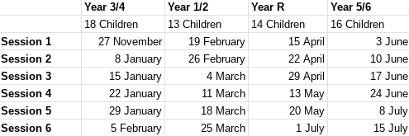
To ensure a safe and comfortable experience, we ask children to come dressed for the weather - see attached leaflet.

