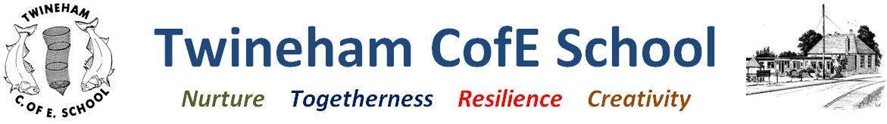
Our Curriculum: Autumn 2023

Outcomes | Texts | Key vocabulary | Curriculum intent
Read a complete book, developing an understanding of character perspectives, empathy, friendship, and how helping each other enhances life.  Write own island survival story.  Locate Japan and recognise key geographical features and make comparisons to the UK  Writing own poems | Kensuke’s Kingdom by Michael Morpurgo  Non-fiction texts on volcanoes and earthquakes  Poems chosen by Michael Rosen | Crater, throat, magma, lava reservoir, vent, conduit, geologist, classify, composite, cinder cone, shield, Ring of Fire, tectonic plate, crust, mantle, outer core, inner core, Northern and Southern Hemispheres, Pacific Ocean, empathy, loyalty, compassion, forgiveness, skipper, metaphors, similes, personification | Children will understand the survival can take many form and often relies on people working together to overcome adversity
Narrative hook | Oakwood Class Year 5-6 (Autumn 2023) |  | Our School Values
Person: A child  Place: An island in the Coral Sea  Problem: Washed up, alone - How do we survive?  Possibilities: Find shelter and food, try to escape the island, make a home there, find another survivor | Inquiry Question: What does it mean to survive?  Concepts: Kensuke’s Kingdom, Japan, Earthquakes and Volcanoes |  | - Togetherness - about friendship and mistakes made, how being together helps us survive  - Resilience- surviving and all areas of sustained learning  - Nurture - for friends/ those in crisis  - Creativity – using resources creatively
Credibility: what will we learn? | Creativity: how will we show our understanding in multiple ways? | Coherence: connections to past and future learning | Compassion: empathy and understanding | Community: local, national and global links
- Map skills to locate nations/geographical features in the Pacific (e.g Ring of Fire/Mount Fuji) and latitude/longtitude references  - Learn features and types of volcano  - Understand causes and consequences of earthquakes  - Compare Japan and UK life | - Story writing  - Map making  - Argument writing and debate  - Create land and cityscapes in art  - Diagrams and explanations  - Poetry reading | - Work on understanding volcanoes will build on the learning about Mount Vesuvius’s eruption which was covered during the Romans topic.  - Learning about the UK and Japan will compare and contrast to learning about other places around the world. Understanding the structure of the Earth will also link forward to Mountains later in the year as will the understanding of risks associated with living near tectonic plate boundaries. | - Making links to compassion and care for others from Bible and Christianity learning  - Exploration of the meaning of friendship  - Understanding the devastating impact of natural disasters in other parts of the world and our duty as global citizens to support people in crisis locally, nationally and globally | - Looking at the news for global events  - Poetry performance to parents

