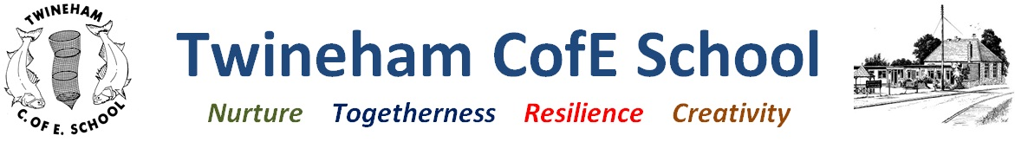

***Everyone is a gift and everyone is gifted***

**Twineham School**

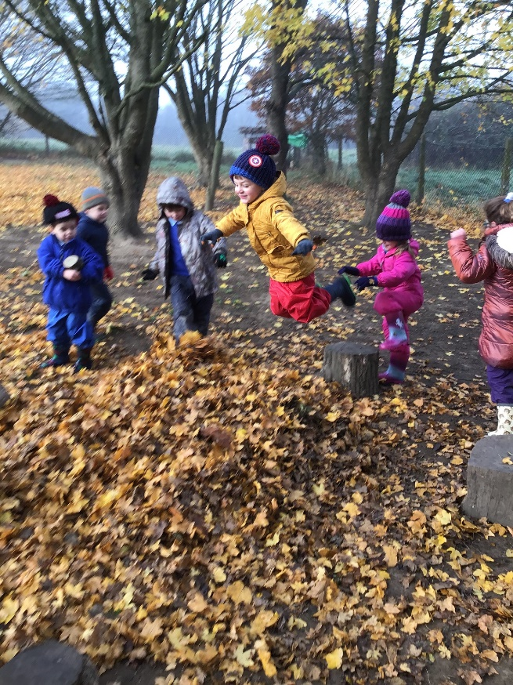 **Handbook**

**September 2024**

**Welcome to Twineham**

We are really glad you have chosen Twineham to be your child’s school. We take pride in our friendly, family atmosphere and look forward to working with you to help your child make a great start to their education with happiness and confidence.

**About the school**

Mrs Sarah Davy is the Headteacher. We have three classes: Buttercups (Reception & Year 1); Willow (Years 2 and 3); Oakwood (Years 4, 5 and 6). These year groupings may change year to year due to differing numbers and needs in each year group. Parents will be informed of their next class teacher and year group towards the end of the Summer term.

Mrs Emily Slade is the class teacher.

Please check our website for up to date details of staff, governors, term dates and much more:[*http://www.twineham.w-sussex.sch.uk/*](http://www.twineham.w-sussex.sch.uk/)

**The School Day**

School has a staggered start time from **8.30 to 8.45am**. You are welcome to drop your child at any point between these times but children *must* be in school by 8.45am. Reception and Year 1 and 2 finish at **3pm**. Key Stage 2 children finish at 3.15pm. Please drop and collect your child from the green school gate. There will be a member of the Buttercup team to welcome your child and bring them into class.

Please make sure you let the school know if someone else is collecting your child at the end of the day. If we don’t know your child is being collected by someone else, even if they are well known to the child, we cannot let your child go with them and will have to call you for confirmation first.

**Part-time and full-time arrangements**

All children should come to school every day. However, we have a flexible policy for doing mornings only or full days, based around the needs of the child. Many parents choose to start mornings only and build up days as they become more settled. Your child’s teacher will work with you to decide what will be best. Children must attend school full-time in the term *following* their 5th birthday. It is important that, if your child attends part-time, that days and timings are kept consistent to help your child to settle and ensure we plan appropriately for them.

**Attendance and holidays**

Good attendance at school is vital. Obviously a child who is ill needs to stay at home, but children who are absent for other reasons risk missing important learning. Head teachers may not grant any leave of absence during term time unless there are exceptional circumstances (such as a funeral). A 5-day holiday involves 10 sessions of school being missed. Holidays cannot be authorised and a fine can be made by West Sussex County Council. Please see our Attendance Policy on our website for more information and details of what can be considered ‘exceptional circumstances’.

The school is closed for 13 weeks every year and term dates are published well in advance, so please use this time for holidays.

**If your child is ill**

Please contact the school by 9:15am either by phone, or email to [office@twineham.w-sussex.sch.uk](mailto:office@twineham.w-sussex.sch.uk) if your child is ill and cannot attend school. It is essential that you provide a reason for any absence. *If your child has sickness and diarrhoea please leave 48 hours since the last bout before returning to school*.

We will always contact you if we think your child is unwell. It is very important that we have up to date contact telephone numbers where we can reach you, or a close family member or friend.

**Medicines and special medical issues**

If your child requires medication in school please complete a form from the office. ALL medicine must be provided in the original packaging & have the Patient Information Leaflet enclosed or we cannot administer it. We are not able to administer non-prescribed medication (apart from paracetamol and antihistamine). Please ensure that you do not give your child any creams or medication to take into school themselves. Please see our Managing Medicines policy for further information.

**Uniform**

All uniform with school logos can be bought from **Monkhouse school wear**; they are a local company based in Haywards Heath run by parents. They offer next working day delivery and a free returns service. The deadline to order uniform for September is usually the end of July.

**School uniform**

* Basic grey skirt/pinafore dress or trousers/shorts
* Light blue blouse/shirt or polo shirt (logo optional)
* Royal blue school cardigan, jumper or sweatshirt with school logo
* White/grey socks or tights
* Blue and white checked gingham dress for girls in summer
* Black shoes or completely black trainers (no heels). Please make sure your child can put these on independently (no laces)
* Wellington boots and waterproof over trousers (to be kept at school for Outdoor Learning)
* Waterproof coat (any colour)

**PE kit**

* Blue sports t-shirt with school logo
* Blue shorts/tracksuit bottoms
* Short white socks
* Trainers (no designer brands, please). Please make sure your child can put these on independently (no laces). We recommend trainers rather than plimsolls as they are easier to run in.

**Optional extras:**

* Reversible coat (fleece/waterproof),

For store details and further information, please visit: https://www.monkhouse.com/school

***Please name all items!***

We also have good quality second hand uniform available for sale which is organised by Friends of Twineham School (FOTS) which is run by parents. If you would like to contact them regarding uniform, please ask the school office for details.

Please be aware that it is possible for your child to wear plain grey leggings/joggers as an alternative to trousers/skirts and plain light blue t-shirts are an alternative to polo shirts if this supports their specific sensory needs. Wearing these *must be agreed* *in advance* between school and parents.

**Drawstring bags** may be bought from the school office (£5 cash) for PE kit & outdoor clothing. You are welcome to provide your own named bag if you prefer.

**Book bags/Rucksacks**. Your child will need to bring a bag in every day. We recommend purchasing a school bookbag from the school office (£6 cash). Please put a keyring on the bag to help your child to identify their bag in the box.

**What to bring each day**

* Book bag and/or small rucksack (with keyring on so that is easily identifiable for your child)
* Named water bottle (no squash or juice please)
* Optional snack. We provide fruit and milk everyday but your child may also bring a small healthy snack in, if they would like. **No nuts** **or seeds** please, and no sweets or chocolate. Please make sure snacks are in a named, easily opened pot.
* Packed lunch in a named box/bag (if you have chosen this option for lunches)

Please encourage your children *not* to bring in any toys as they can be easily lost or broken. If they have a special comfort object, please discuss this with their teacher. They will have the opportunity to show toys or special items from home on their ‘Show and Share’ days.

**Lunches**

**Hot School dinners**

All children in Reception, Year 1 and Year 2 are entitled to a free hot lunch, provided by Chartwells catering company. This must be booked online via ParentPay. Any dietary requirements should be advised when you purchase your child’s meals via ParentPay. **Please note meals must be purchased a minimum of two weeks in advance.** Any enquiries regarding school meals should be directed to Chartwells.

We encourage children to try everything. We will monitor how much they eat when they start school and let you know if we have any concerns.

**Packed lunches**

If you choose not to take up the offer of free hot meals, please provide your child with a packed lunch. We do not empty the lunchboxes when your child finishes; this is so that you can see how much they have eaten when they come home. We do not let the children swap food and encourage them to eat the savoury items first. Please note we have a ***no nuts or seeds policy*** as we do have children in school that are severely allergic to both.

**Treats**

Please note it is ***not*** school policy for children to bring in sweets or cakes to celebrate birthdays. We do sing happy birthday to them and make sure they feel special though! Children may wear their own home-clothes on their birthday.

**A note on parking and dropping off on Church Lane**

Please drive slowly and carefully and watch out for pedestrians walking in the lane. There is a voluntary code for the lane which outlines our preferred give way.

**Voluntary code for the lane**

1. Watch your speed down the whole lane.

2. No parking in the drop-off zone in the morning – this area should keep flowing and is designed to ‘drop and go’ and is not a parking area

3. No parking at any time on the roundabout, in the yellow hatched area or in the staff car park. Please do not walk through the staff car park either – there are reversing cars and the space is small.

4. No parking on the corners of the roundabout or by the five-bar gate into school.

5. Cars leaving the school should be given right of way wherever possible.

6. Take special care and drive slowly entering the lane.

**What will my child be learning in Reception?**

In Reception children are learning all the time through carefully planned play opportunities and group times. The teachers will watch your children’s learning and plan carefully designed activities to move the children on in their learning. The children will be encouraged to be independent, use their imagination, get on with each other, be creative and explore the world. All learning takes place in our inside and outside areas. We know children are individuals and learn at different rates and this is always taken into account. The work is planned around the seven areas of learning:

* Personal, Social and Emotional Development
* Communication and Language
* Physical Development
* Literacy
* Maths
* Understanding the world
* Expressive Arts and Design

These are set out in the Early Years Foundation Stage, which is statutory guidance for all adults working with 0-5 year olds. Children are assessed in the seven areas throughout the year and your input is a valuable part of us building up a picture of your child.

*You will be able to find out much more about the curriculum and how we teach it at our “6 weeks in Meeting” in October.*

**Ways you can help your child make the best start at school**

* Keep in touch. Use the ‘Seesaw’ app to communicate with Buttercups class and check it regularly (daily if possible). Let us know straight away if you have any questions or concerns. You can always catch us at the end of the day for a quick chat or to pass on messages. You can also call/email the office to arrange a phone call or appointment. When your child starts school we will also set up an ‘E-Schools’ account for you to access all school newsletters and information.
* Please help us by supporting your child to go to the toilet independently. Boys need to practise lifting the toilet seat and aiming accurately. Please also teach children to wipe themselves and know about flushing the toilet and washing their hands. If your child is not confident in any area of toileting or self-care, please don’t worry or be embarrassed; just let us know at home visits and we can support your child with it.
* Make sure children can be as independent as possible. Help them to practice putting their coats and shoes on, hang items on pegs, use a knife and fork, and open and close snack pots and water bottles by themselves.

***Thank you again for choosing Twineham. We can’t wait to get to know you.***